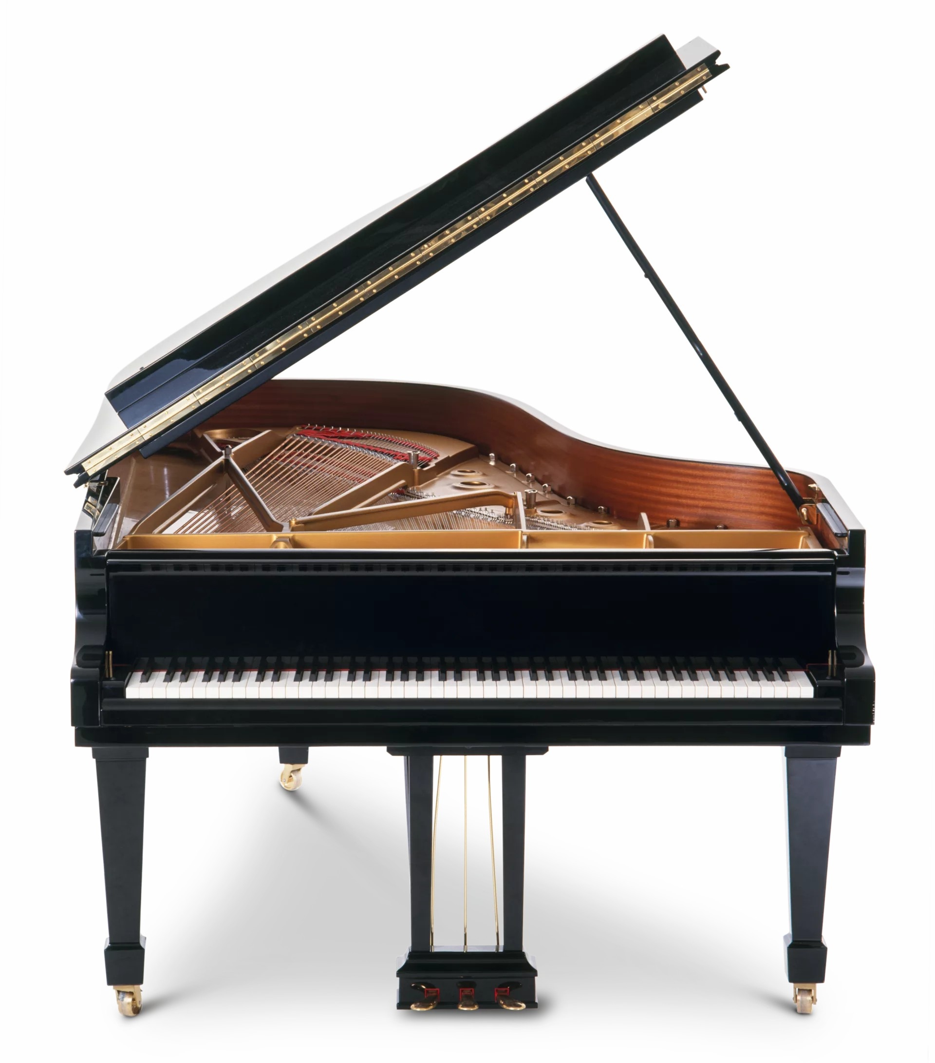
Sunday, November 8th, 7:30pm
Melrose Parish Church Hall

Melrose Music Society
SCOTTISH CHARITY NO. SC005891

2

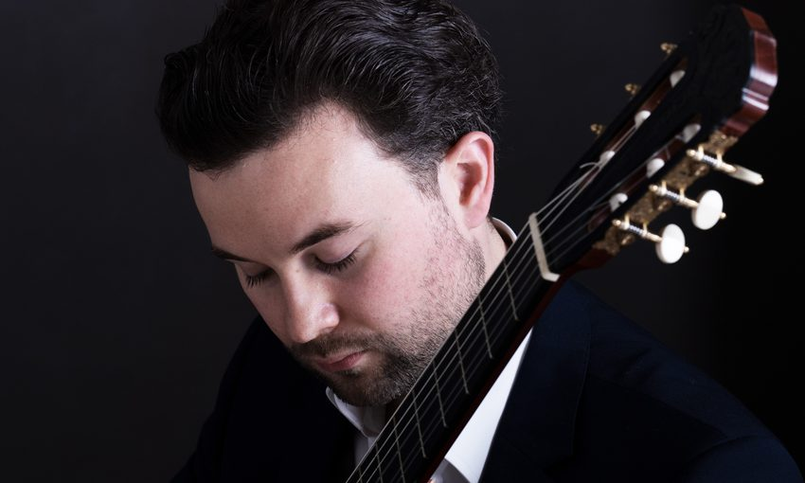
Ian Watt, guitar – Pieces of Picasso
Fernando Sor: Minuet in C minor Op 24; Rondo in C major, Op. 22
Stephen Goss: Cantigas de Santiago
Giulio Regondi: Introduction and Caprice
Michael Tippett: The Blue Guitar
Miguel Llobet: Scherzo-Vals; El Mestre
Emilio Pujol: Las Abejas; Guajira; Canción de Cuna;

Adults £20; Students/UC/PC/under-25s £10;
Accompanied Children Free

www.ticketebo.co.uk/melrose-music-society

info@melrosemusicsociety.org.uk

melrosemusicsociety.org.uk

