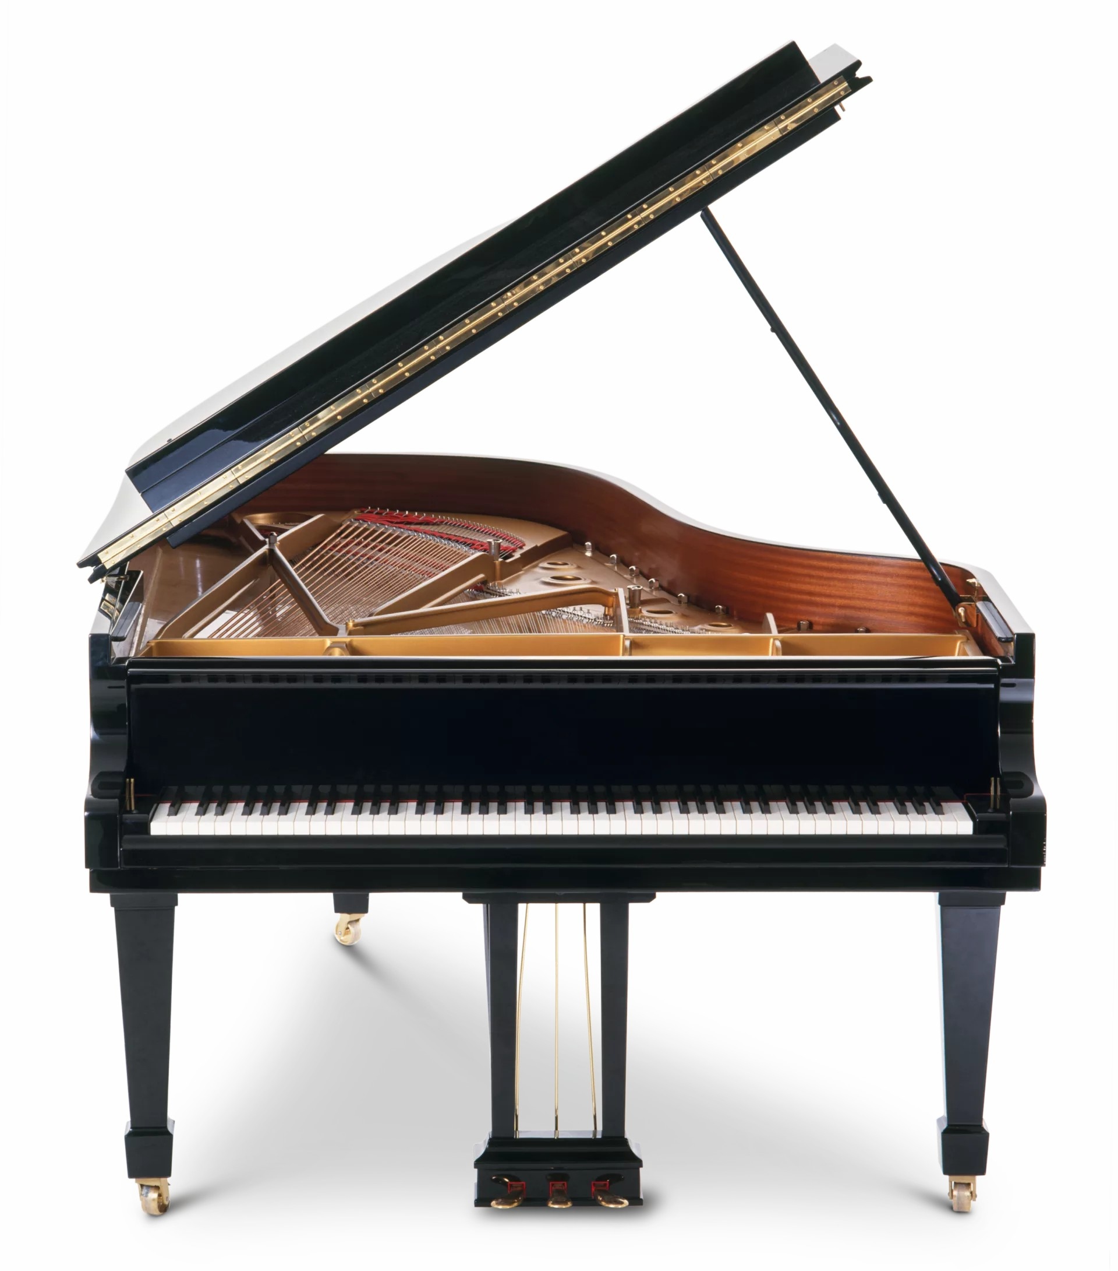
Sunday July 19th 3pm
Melrose Parish Church Hall

Melrose Music Society
SCOTTISH CHARITY NO. SC005891

2

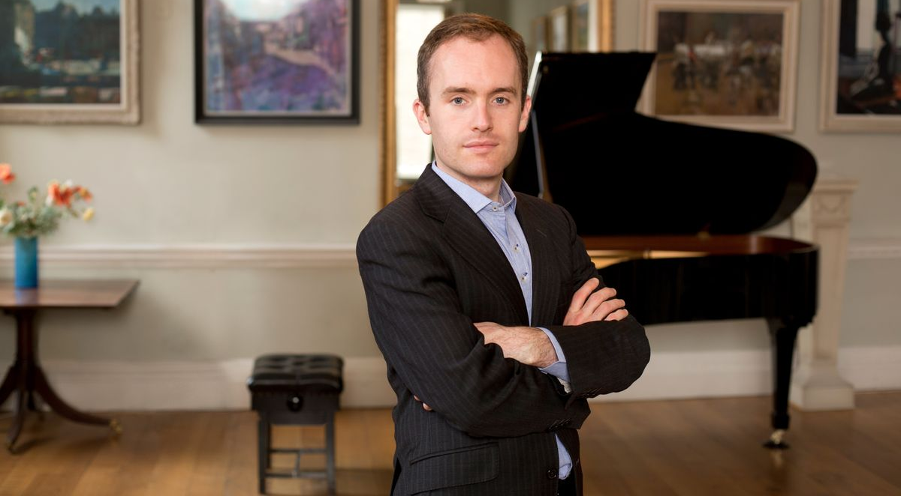
Simon Callaghan, Piano - Early 20thC English Composers & Schuberts Last Sonata

Adults £20; Students/UC/PC/under-25s £10;
Accompanied Children Free

www.ticketebo.co.uk/melrose-music-society

info@melrosemusicsociety.org.uk

melrosemusicsociety.org.uk
Rebecca Clarke: Theme and Variations
Cyril Scott: Sonata No.1
Franz Schubert: Sonata in B-flat major, D. 960

