Melrose Music Society
SCOTTISH CHARITY NO. SC005891

Sunday 31st May, 2026, 3pm

Concert Royal –
Music for a Georgian Drawing Room
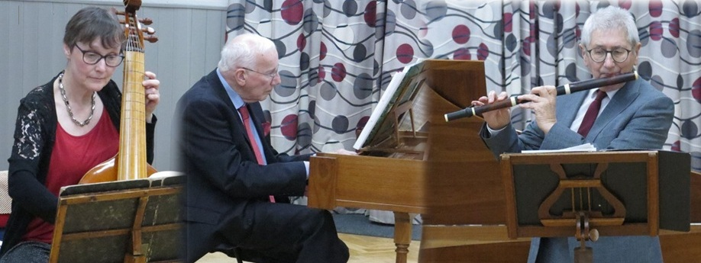

Peter Harrison, flute
Rachel Gray, violoncello/bass viol
John Treherne, harpsichord

J.Oswald: The Ranunculus
J.Gunn: Four Favourite Scotch Airs for a Flute and a Violoncello
J.E.Galliard: Violoncello Sonata
Dr.E.Miller: Harpsichord Sonata
J.Oswald: The Crocus

Interval

C.F.Abel: Viola da Gamba Sonata
J.C.Bach: Sonata for Flute and Harpsichord
G.F.Handel: Fantasia for Harpsichord; Musik for the Royal Fireworks

James Oswald (1710 – 1769): The Ranunculus; The Crocus
James Oswald, the son of a town musician in Crail, taught dancing in Dunfermline before moving to Edinburgh to become a leading figure in one of the first Scottish chamber music societies, where members, for an annual fee of one guinea, could enjoy concerts every Friday night in Mary’s Chapel, Niddry Wynd. Oswald published his first Curious Collection of Scots Tunes, dedicated to the Duke of Perth in 1740, but, the following year, sought greater fame and fortune in London, much to the chagrin of the Edinburgh-based poet, Allan Ramsay, who complained, “Alas! no more shall thy gay tunes delight, No more thy notes sadness or joy excite, No more thy solemn bass’s awful sound Shall from the Chapel’s vaulted roof rebound. London, alas! which aye has been our bane, To which our very loss is certain gain, If they thy value know as well as we, Perhaps our vanished gold may flow to thee.” Gold certainly did flow to Oswald: a year after George III succeeded to the throne, he appointed him “Chamber Composer to the King.” Oswald set up his own publishing house, popularising Scottish music in England, and thus throughout Europe, with his Caledonian Pocket Companion, including many of the melodies now associated with lyrics by Burns, such as “Ae Fond Kiss”. Oswald was adept in many styles and genres, composing theatre music and numerous military marches, satirical songs, ballads and love songs. His most remarkable creations are his "Airs for the Seasons", composed between 1755 and 1761: 96 pieces representing a different flower or shrub, the Ranunculus (or buttercup) and Crocus both included in “Spring”. The former has four movements – moderato, allegro andante, tempo di minuetto, giga; the latter two - moderato – allegro.

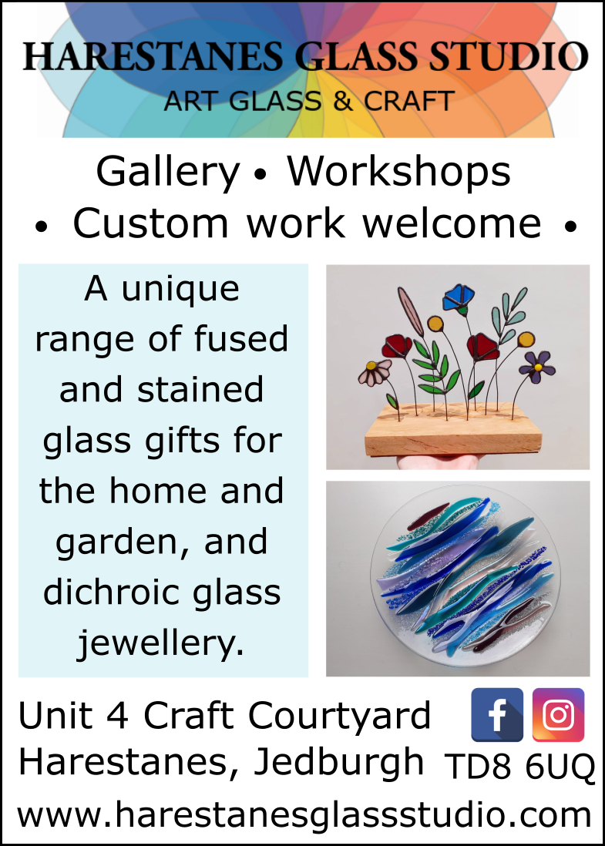

John Gunn (1766–1824) - Love is the Cause of my Mourning;
The Braes of Ballenden;
The Bonny Grey-Eyed Morning;
The Boat Man
Gunn was a cellist, flautist, teacher and author. Born in Sutherland. He taught cello and flute in London and Cambridge, and wrote influential treatises on instrumental technique, music theory and Scottish cultural history. His arrangements of “40 Favourite Scotch Airs for Violin, Flute, or Cello” published in 1789 provided engaging material for his students and amateur musicians generally, “favourite” being no exaggeration for Scottish tunes were immensely popular in C18th London. “Love is the cause of my Mourning” was the big hit from Joseph Mitchell’s The Highland Fair, performed at the Theatre-Royal, Drury-Lane, by His Majesty's servants in 1731; Johann Christian Bach had made a very successful adaptation of “The Braes of Ballenden” for voice, piano, oboe, violin, viola & cello, in May, 1779; "Bonny Gray-eye'd Morn" was probably composed, and certainly popularised, by English composer, Jeremiah Clarke – famous for the Trumpet Voluntary – for a revival of D'Urfey's comedy The Fond Husband in 1696. All three had been included in Oswald’s Caledonian Pocket Companion. “The Boat Man”, in contrast, was a recent Gaelic love song by Sìne NicFhionnlaigh (Jean Finlayson) of Tong, dedicated to a young fisherman from Uig, Dòmhnall MacRath, whom she happily went on to marry. The song, though, is a haunting, mournful lament, which, with English lyrics, became a great favourite in London taverns in the 1780s.
Johann Ernst Galliard (1687–1747) - Violoncello Sonata
affetuoso - spiritoso - larghetto e cantabile – menuet
Galliard was the son of a hairdresser from Zell in what is now Germany. A virtuoso oboist, he studied composition with Farinelli, a close friend of Handel’s, and the concert master at Hanover. Galliard’s life took a dramatic turn in 1706 when George, Prince of Denmark and consort of Queen Anne visited, was impressed by his musical prowess, and invited him to London, where he became principal oboist at the Queen’s theatre for their opera productions, inspiring Handel to compose ornate solo parts for him. He was, in 1726, a founding member of the Academy of Ancient Music and the Royal Society of Musicians in 1738. His compositions skilfully blend German, French, and Italian styles. His “Six Sonatas for the Bassoon or Violoncello with a Thorough Bass for the Harpsichord”, were published in 1733.

Edward Miller (1731–1807) - Harpsichord Sonata
allegro - largo - gigue
Born in Norwich to a family earning a meagre living from paving streets and operating a boarding house, Miller displayed surprising musical talent from an early age. He left home as a teenager to study under organist Charles Burney in King's Lynn, where he was introduced to George Frideric Handel. He moved to Doncaster in 1756 to serve as organist at St. George's Church, a position he held for over fifty years, elevating the town's musical culture through regular concerts, inspiring teaching and a steady stream of compositions, including flute solos, harpsichord pieces, anthems, psalm settings, organ voluntaries and over three hundred hymn tunes for John Wesley, perhaps the best-known being “When I Survey the Wondrous Cross”. In 1786, Cambridge University awarded him a Doctor of Music degree in recognition of his achievements. This simple but accomplished sonata was published in 1771.

Carl Friedrich Abel (1723 – 1787) - Viola da Gamba Sonata
vivace – adagio – minuetto
Carl Friedrich Abel capitalised on a musical pedigree with strong links to the Bach family. His father, Christian Friedrich, had been the chamber cello and viol player in Cöthen when Johann Sebastian Bach was appointed Capellmeister, the two developing a close professional and personal relationship. When Abel Senior died in 1737, Carl Friedrich was sent to live with the Bach family, who had moved to Leipzig. There, he learned the skills that dazzled audiences in a glittering career of improvised virtuoso performances on the viola da gamba and harpsichord. He was director of music at the Dresden court from 1743, and moved to London in 1759, becoming chamber musician to Queen Charlotte in 1764. From 1763 he shared a house with Johann Christian Bach (whom he had known in Leipzig as a young man) and together they ran the Wednesday Evening Concerts at Carlisle House in Soho Square, the forerunner to the more celebrated Bach–Abel Concerts in Hanover Square. Abel’s Six Sonatas (WK 141–146) date from the 1770s, when this pioneering concert subscription series was at its peak. Relatively straightforward pieces, they were written to attract enthusiastic amateurs of relatively modest ability on the instrument, yet display Abel’s considerable melodic gifts, and would have served as a launching pad for his improvisations and decorations.

Johann Christian Bach (1735-1782) - Sonata for flute and harpsichord
allego assai - andante grazioso
Johann Christian Bach, born in Leipzig, was the youngest of Johann Sebastian’s five sons. After his father's death, he moved to Berlin to study music with his half-brother Carl Philipp Emanuel Bach, twenty-one years his senior. In 1754 he moved to Bologna and was appointed organist at Milan Cathedral in 1760. In 1762, he travelled to London to première three operas at the King's Theatre, including Orione on 19 February 1763, which established his reputation in England. He became music master to Queen Charlotte, and in 1777, won a landmark court case that established that copyright law applied to musical scores, thus curtailing the haphazard, chaotic proliferation of unauthorised versions of popular pieces, such as Handel’s Musik for the Royal Fireworks. His sonata in D Major Op. 16 No.1 was published in 1780.


George Frideric Handel (1685-1759) - Fantasia for Harpsichord;
Musik for the Royal Fireworks
allegro (La Rejouissance) - largo alla siciliana (La Paix)
bourree - menuet I - minuet II
Born in Halle, Handel spent his early life in Hamburg and Italy before settling in London in 1712, where he spent the bulk of his career and became a naturalised British subject in 1727. Influenced by the middle-German polyphonic choral tradition and by the Italian Baroque, he brought Italian opera to its highest development, created the genres of English oratorio and organ concerto, and revolutionised English church music. His twelve Fantasias were compiled by the composer from his improvisations in Italy between 1706 and 1710. He settled permanently in England in 1713, after receiving a yearly income of £200 from Queen Anne for the Utrecht Te Deum and Jubilate, composed at her request. The Music for the Royal Fireworks was written in 1749 for King George II to celebrate the end of the War of the Austrian Succession. A pavilion over four hundred feet long was built especially for the event in Green Park, and the music was to be the accompaniment of an immense pyrotechnic display. Originally the king insisted on using “martial instruments” (brass, woodwind and percussion), presumably to match the event. However, after its premiere Handel reworked the ensemble to suit his original wishes, and the ensemble was changed to include string instruments. Almost immediately, given the lack of any copyright enforcement, numerous transcriptions and arrangements were made so this popular work could be heard in domestic surroundings.

York based musician Peter Harrison studied flute at the Birmingham Conservatoire and music performance at York University. In October 1971, he founded Concert Royal, one of Britain’s longest established early music groups, with harpsichordist John Treherne, soon joined by another York-based musician, cellist Rachel Gray. For over fifty years they have recreated the musical sound world of the eighteenth and early nineteenth centuries through research, study and performance on historic instruments. They have given hundreds of recitals in every corner of the UK, performing in festivals and for music and arts societies, in churches, schools, and arts centres. The ensemble has toured in Europe, the USA and for the British Council in South America. Rachel also performs regularly with the Yorkshire Baroque Soloists, 18th Century Concert Orchestra, Newcastle Baroque and many other period instrument ensembles including Manchester Baroque and English Haydn Festival Orchestra. She teaches Baroque Cello at the University of York where she also co-directs the University Baroque Ensemble. Peter lectured in education at the University of Hull for twenty years, and his edition of Handel’s Musick for the Royal Fireworks has been published by Oxford University Press. John has taught at all the universities in North East England, and has worked with children from nursery age to 6th Form.

Our Next Concert
Sunday, June 28th 3pm – The Bute Wind Quintet
We feature more flute, but in a very different context. We celebrate György Kurtág’s 100th birthday with one of his earliest works, alongside music by composers with rather intimidating reputations. Fear not: Ligeti here is at his liveliest, quirkiest and wittiest; Berio’s amusing “entertainment for children” is a set of animal impressions; Stockhausen’s elegy is sublimely poignant. All these contrasting moods mingle in the greatest wind quintet ever composed: if you like the lush mysticism of Verklärte Nacht, you will be utterly entranced by Schoenberg’s Op.26.
György Ligeti: Six Bagatelles; György Kurtág: Wind Quintet, op.2; Luciano Berio: Opus Number Zoo; Karlheinz Stockhausen: Adieu; Arnold Schoenberg: Wind Quintet, Op. 26

Our Next Work by a Scottish Composer
Sunday, Sept. 27th, 3pm – Duo B!z’art, piano four-hands
We celebrate the 150th anniversary of Bruno Walter’s birth with his astonishing transcription of Mahler’s Symphony No 1, “The Titan”, played by the Belgian duo of André Roe and Geoffrey Baptiste, who have, over the last two decades, become one of the top piano duos in Europe. Leonard Bernstein began his career as Walter’s assistant at the NYPO, making his sensational debut at Carnegie Hall in 1943 when the German refugee was ill with ‘flu, so it is appropriate that we will hear his West Side Story Suite. His fellow American, and friend, John Corigliano’s Gazebo Dances are exuberant, exhilarating foot-tappers. Strange and Solemn Music by Scotland’s John Hearne is as moody and evocative as its Shakespearean title suggests.
John Corigliano: Gazebo Dances; John Hearne: Strange and Solemn music;
Leonard Bernstein: West Side Story Suite; Gustav Mahler, arr. Walter: Symphony No.1

Our Next Music by a Member of the Bach Family
Sunday, Oct. 25th, 3pm – Nikodem Rodzeń, violin
Johann Christian’s father, Johann Sebastian Bach wrote the greatest pieces for solo violin ever composed. His second partita, culminating in the famous plaintive, searingly beautiful, Ciaccona contrasts remarkably with his sunny, lilting Preludio and Loure in E Major. Grażyna Bacewicz, renowned during her lifetime as an exceptionally talented violinist, is now recognised as one of the finest, most engaging, composers of the last century, her works for her own instrument being particularly uplifting. A performance of Berio’s intense, passionate, technically demanding (a euphemism for “almost impossible”) Sequenza VIII is an unforgettably exhilarating experience, with gorgeous moments of serenity amid the mayhem. We are lucky to have a charismatic young virtuoso from Warsaw to perform this irresistible programme of undoubted masterpieces, exploring the full range of emotions.
J. S. Bach: Partitas: No.2 in D Minor; No.3 in E Major, Preludio and Loure;
Luciano Berio: Sequenza VIII; Grażyna Bacewicz: Sonata No. 2; Kaprys Polski

Please volunteer - although we have been putting on concerts of the highest musical calibre since the early 1960s, we remain a very small operation relying entirely on a few volunteers to organise and manage our activities. If you think you might be able to help in any way by, for example, transporting musicians to and/or from Tweedbank or Berwick station, providing overnight accommodation, serving refreshments during the interval, creating publicity materials, putting up posters, please, do contact us.

Website – www.melrosemusicsociety.org.uk
Email - info@melrosemusicsociety.org.uk


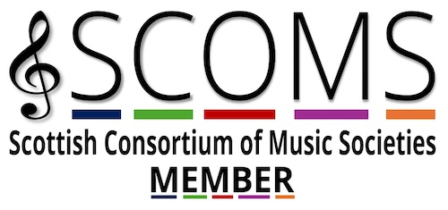
Tickets - www.ticketebo.co.uk/melrose-music-society
Our ticket prices are unrealistically low because we believe great music should be accessible to anyone regardless of income. If you can afford more, please, give a little extra. All donations are greatly appreciated. Equally, while we wish you a long, healthy life, a bequest, however small, would help the Society to keep organising concerts into the future.

We thank Creative Scotland, through Chamber Music Scotland, for their invaluable financial help.

We are founder members of the Scottish Consortium of Music Societies.

